https://www.facebook.com/profile.php?id=61552006482448&mibextid=ZbWKwL



**Log In**

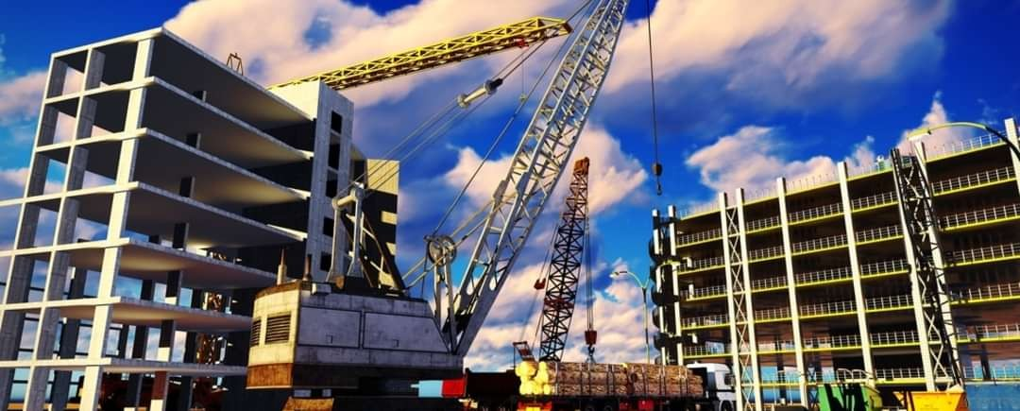

AK builders

**0** likes **0** followers



**Follow**

Posts About Photos Mentions

# Details

**Page** · Construction company

Not yet rated (0 reviews)

**AK builders** updated their proﬁle

picture.

11 Oct 2023





**Log In**